December 7, 2016

Contact specialized press
Beate Adams
Communications Business Line Silanes
Phone +49 6181 59-13628
Fax +49 6181 59-713628
beate.adams@evonik.com

Evonik Resource Efficiency GmbH
Rellinghauser Straße 1-11
45128 Essen
Phone +49 201 177-01
Fax +49 201 177-3475
www.evonik.com

Supervisory Board
Dr. Ralph Sven Kaufmann, Chairman

Executive Board
Dr. Claus Rettig, Chairman
Dr. Johannes Ohmer,
Simone Hildmann,
Alexandra Schwarz

Registered Office: Essen
Register Court: Essen Local Court
Commercial Registry B 25783
VAT ID no. DE 815528487

Evonik shows customized invisible protection systems containing Protectosil® at BAU 2017

Silane-based corrosion control systems such as Protectosil® CIT preserve and extend the service life reinforced concrete structures

Protectosil ANTIGRAFFITI® keeps buildings graffiti free

Protectosil® water repellents protect buildings

At BAU 2017 in Munich, Evonik will be showing a wide range of Protectosil® products for the protection of buildings and structures constructed with building materials such as concrete, brick, and natural stone. The silane-based systems penetrate deep into the construction material, preserving it from damage and deterioration. The Silanes Business Line has more than 50 years of global expertise in the development, application, and production of silanes for building protection. The product portfolio comprises a wide range of building protection products, formulated to work on a variety of building substrates. Evonik’s silane based building protection products are suitable as water repellents, corrosion inhibitors, as well as easy-clean and anti-graffiti surface protection.

Corrosion protection
Silane-based corrosion protection systems such as Protectosil® CIT protect reinforced concrete structures against damage and deterioration; this allows major savings for both public and privately owned buildings, bridges, and car parks.

The award-winning Protectosil® DRY CIT is the first concrete admixture in powder form that protects reinforced concrete against corrosion. Significant extension of service life can be realized by incorporating our corrosion inhibiting silane technology into your design plan. Corrosion protection with Protectosil® is scientifically proven. In addition to increasing service life and durability to new reinforced concrete structures, it is also suitable for repair and maintenance of building structures that have already been damaged.

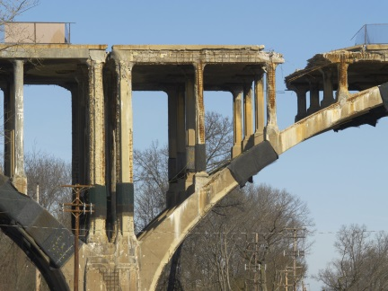
Caption:
Protectosil® can effectively prevent occurrence of dangerous damage in bridges.

Protection against graffiti
Damage by graffiti is no longer an isolated occurrence, the protection of buildings against graffiti is becoming increasingly important. Prevention as well as removal should be fast, efficient, and cost-effective.

Protectosil ANTIGRAFFITI® is hydrophobic and oleophobic, which means that coatings, marker inks, and oil- or water-based paints cannot penetrate into the pores of the structural material. Spray paint runs down immediately on application, so that the graffiti artist finds it much harder to complete his graffiti. Additionally, surfaces defaced by graffiti are easily cleaned. Protectosil ANTIGRAFFITI® is ready to use and cost-effective: It acts as a long-term protective system, allowing at least 10 cleaning cycles.

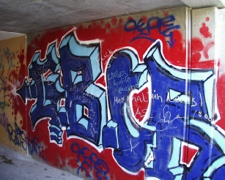
Caption:
Protectosil ANTIGRAFFITI® keeps buildings graffiti free.

Hydrophobing
Moisture is usually the main cause of damage and common denominator to many degradation processes that occur in mineral building materials. The porous structure of building materials allows water, and the pollutants dissolved in it, to penetrate easily into the interior of the building. Prevention of water penetration by Protectosil® hydrophobing products protects against, for example, efflorescence and freeze-thaw damage.

Even after treatment with Protectosil® products the building structure retains its breathability, so that moisture can continue to evaporate to the exterior. The deep penetrating silane remains unaffected by UV radiation or environmental pollution. The surface of the material remains visually unchanged after Protectosil® application.

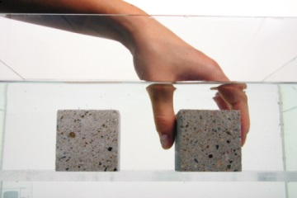

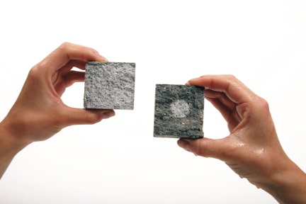

Test
A test specimen hydrophobized with Protectosil® BHN (on the left in both photos) and an untreated specimen (on the right in both photos) were dried for 2 weeks and then submerged in water for 3 to 12 hours. After only 3 hours the untreated specimen was completely penetrated by water, except for a small core area. The stone protected with Protectosil® BHN showed no water penetration.

Further information on building protection with Protectosil® is available at www.protectosil.com

Learn more about silanes in building protection at our stand, 415, in Hall A 1 at BAU in Munich between January 16 and 21, 2017.

Company information
Evonik, the creative industrial group from Germany, is one of the world leaders in specialty chemicals, operating in the Nutrition & Care, Resource Efficiency and Performance Materials segments. The company benefits from its innovative prowess and integrated technology platforms. In 2015 more than 33,500 employees generated sales of around €13.5 billion and an operating profit (adjusted EBITDA) of about €2.47 billion.

About Resource Efficiency
The Resource Efficiency segment is led by Evonik Resource Efficiency GmbH and supplies high performance materials for environmentally friendly as well as energy-efficient systems to the automotive, paints & coatings, adhesives, construction, and many other industries. This segment employed about 8,600 employees, and generated sales of around €4.3 billion in 2015.

Disclaimer
In so far as forecasts or expectations are expressed in this press release or where our statements concern the future, these forecasts, expectations or statements may involve known or unknown risks and uncertainties. Actual results or developments may vary, depending on changes in the operating environment. Neither Evonik Industries AG nor its group companies assume an obligation to update the forecasts, expectations or statements contained in this release.

